**Exercise - Create an express application to send user information from form using GET and POST methods**

**Implementation: GET methods**

**Program:**

**Register.html:**

<h1>Registeration Page</h1>

<br>

<form action="formSubmit" method="get">

    <input type="text" placeholder="Enter your Name" name="name" id="name"/><br>

    <input type="text" placeholder="Enter your City" name="city" id="city"/><br>

    <input type="submit">

</form>

**Index.js:**

// Import the Express module

const express = require('express');

// Create an Express application

var app = express();

// Define a route handler for the '/register' GET request

app.get('/register', function (req, res) {

  // Send the 'register.html' file from the current directory ('__dirname')

  res.sendFile(__dirname + '/register.html');

});

// Define a route handler for the '/formSubmit' GET request

app.get('/formSubmit', function (req, res) {

  // Extract the user's input from the query string

  const name = req.query.name;

  const city = req.query.city;

  // Send a response message using the extracted user input

  res.send('Your Name is ' + name + ' and Your city is ' + city);

});

// Start the Express application and listen on port 7090

app.listen(7090);

**Note:**

**Open your web browser and navigate to <http://localhost:7090/register>**

**This will open the registration form.**

**Output:**



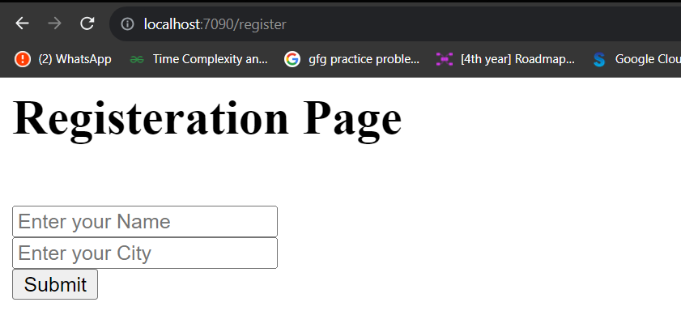

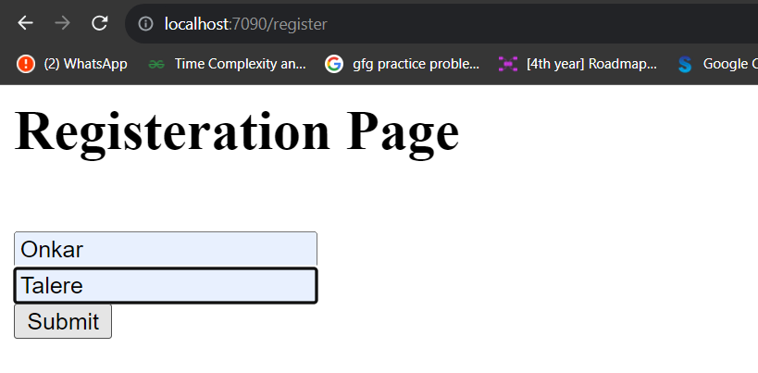

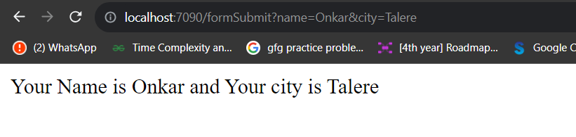

**Implementation: Post Methods using body-parser**

**Program:**

**Register.html**

<h1>Registeration Page</h1>

<br>

<form action="formSubmit" method="post">

    <input type="text" placeholder="Enter your Name" name="name" id="name"/><br>

    <input type="text" placeholder="Enter your City" name="city" id="city"/><br>

    <input type="submit">

</form>

**Index.js**

const express = require('express');

var app = express();

// Import the body-parser module to parse incoming JSON and URL-encoded form data

var bodyparser = require('body-parser');

// Use the body-parser.json() middleware to parse JSON data

app.use(bodyparser.json());

// Use the body-parser.urlencoded({extended:true}) middleware to parse URL-encoded form data

app.use(bodyparser.urlencoded({ extended: true }));

// Define a route handler for the '/register' GET request

app.get('/register', function (req, res) {

  // Send the 'register.html' file from the current directory ('__dirname')

  res.sendFile(__dirname + '/register.html');

});

// Define a route handler for the '/formSubmit' POST request

app.post('/formSubmit', function (req, res) {

  // Extract the user's input from the request body

  const name = req.body.name;

  const city = req.body.city;

  // Send a response message using the extracted user input, emphasizing the name and city using HTML tags

  res.send("Your Name is <b>" + name + "</b> and Your city is <b>" + city + "</b>");

});

// Start the Express application and listen on port 7091

app.listen(7091);

**Note:**

**Open your web browser and navigate to <http://localhost:7090/register>**

**This will open the registration form.**

**Output:**



